EXP NO 6
CAKE ORDERING SYSTEM

Aim
To develop a Cake Ordering webpage that allows users to enter their name, select a cake type, choose a delivery date, and receive order confirmation with an order ID.
Procedure
- Create the webpage using HTML.
- Add input fields for customer name and delivery date.
- Provide a dropdown menu to select the cake type.
- Add a Place Order button.
- Use JavaScript to validate the details and generate an order ID.
- Display the order confirmation with customer details.
Code
<!DOCTYPE html>
<html>
<head>
<title>Cake Order</title>
</head>
<body>

<h2>Cake Ordering System</h2>

Name:<br>
<input type="text" id="name"><br><br>

Cake:<br>
<select id="cake">
<option>Chocolate</option>
<option>Vanilla</option>
<option>Red Velvet</option>
</select><br><br>

Date:<br>
<input type="date" id="date"><br><br>

<button onclick="order()">Place Order</button>

<p id="result"></p>

<script>
function order(){
let n=name.value;
let c=cake.value;
let d=date.value;

if(n==""||d==""){
alert("Enter all details");
}
else{
result.innerHTML="<h3>🎂 Order Confirmed</h3>"
+"Name: "+n+"<br>"
+"Cake: "+c+"<br>"
+"Date: "+d+"<br>"
+"Order ID: CK"+Math.floor(Math.random()*10000);
}
}
</script>

</body>
</html>

Output
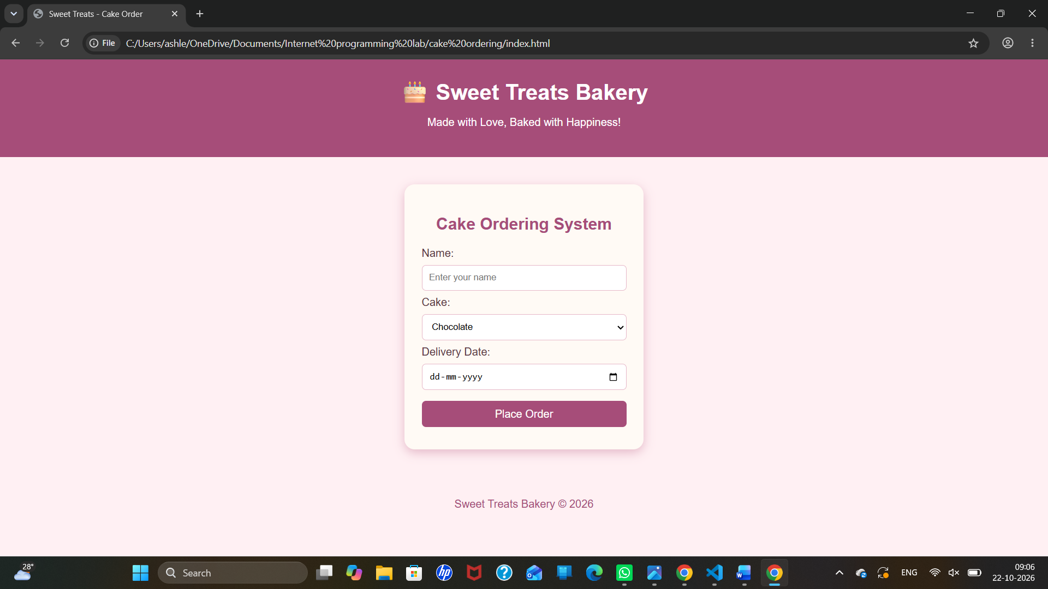

Result
Thus, the Cake Ordering webpage was created successfully with customer details, cake selection, delivery date, input validation, and order confirmation.

